1.64: a) 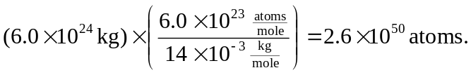

- The number of neutrons is the mass of the neutron star divided by the mass of a neutron:

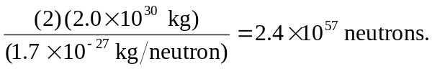
c) The average mass of a particle is essentially the mass of either the proton or the neutron, 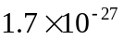 kg. The total number of particles is the total mass divided by this average, and the total mass is the volume times the average density. Denoting the density by ρ (the notation introduced in Chapter 14).

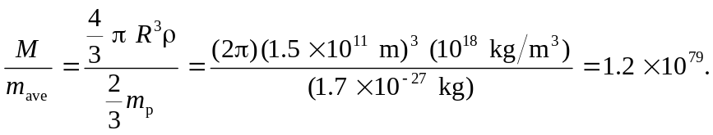
Note the conversion from g/cm³ to kg/m³.

